31) Calculate the water bill given the cubic feet of water used for Eureka Water Company, which charges the homeowner one of the following.

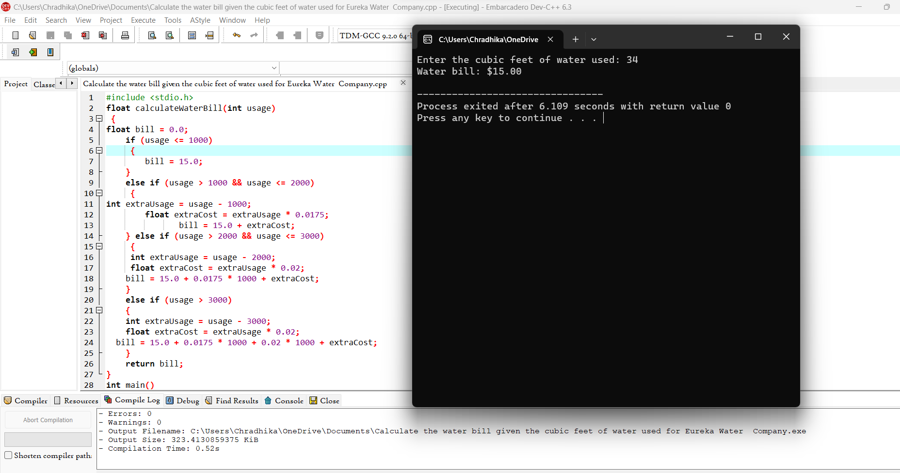

32) A company that issues check-cashing cards uses an algorithm to create card numbers

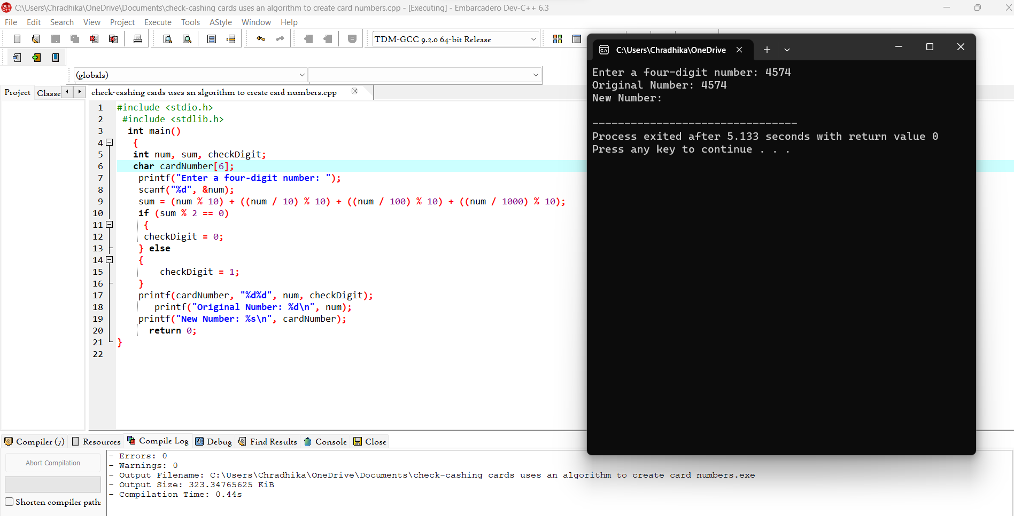

33) An admission charge for The Little Rep Theatre varies according to the age of the person

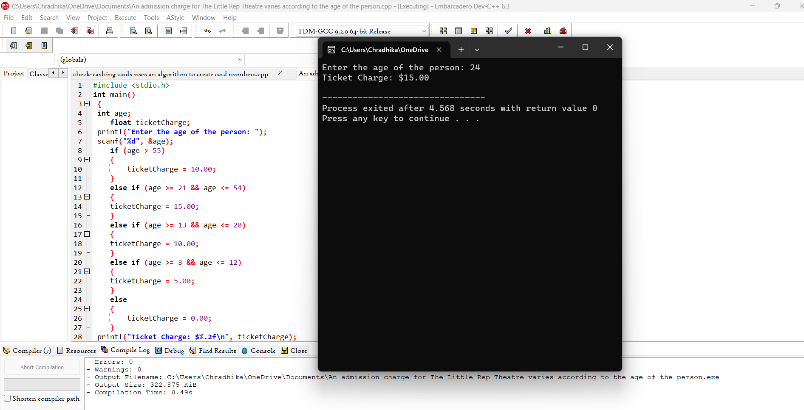

34) A hotel has a pricing policy as follows



35) A student wants to know his grade point average for the semester

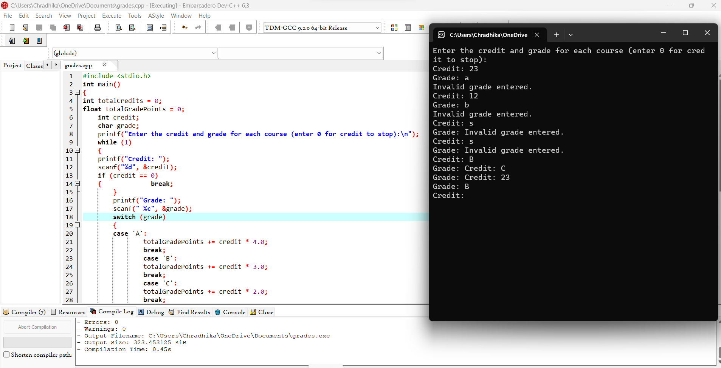

**36)** Mr. Johnson would like to know how many As, Bs, Cs, Ds, and Fs his students received on a test.



37) John Smith is a new car salesperson

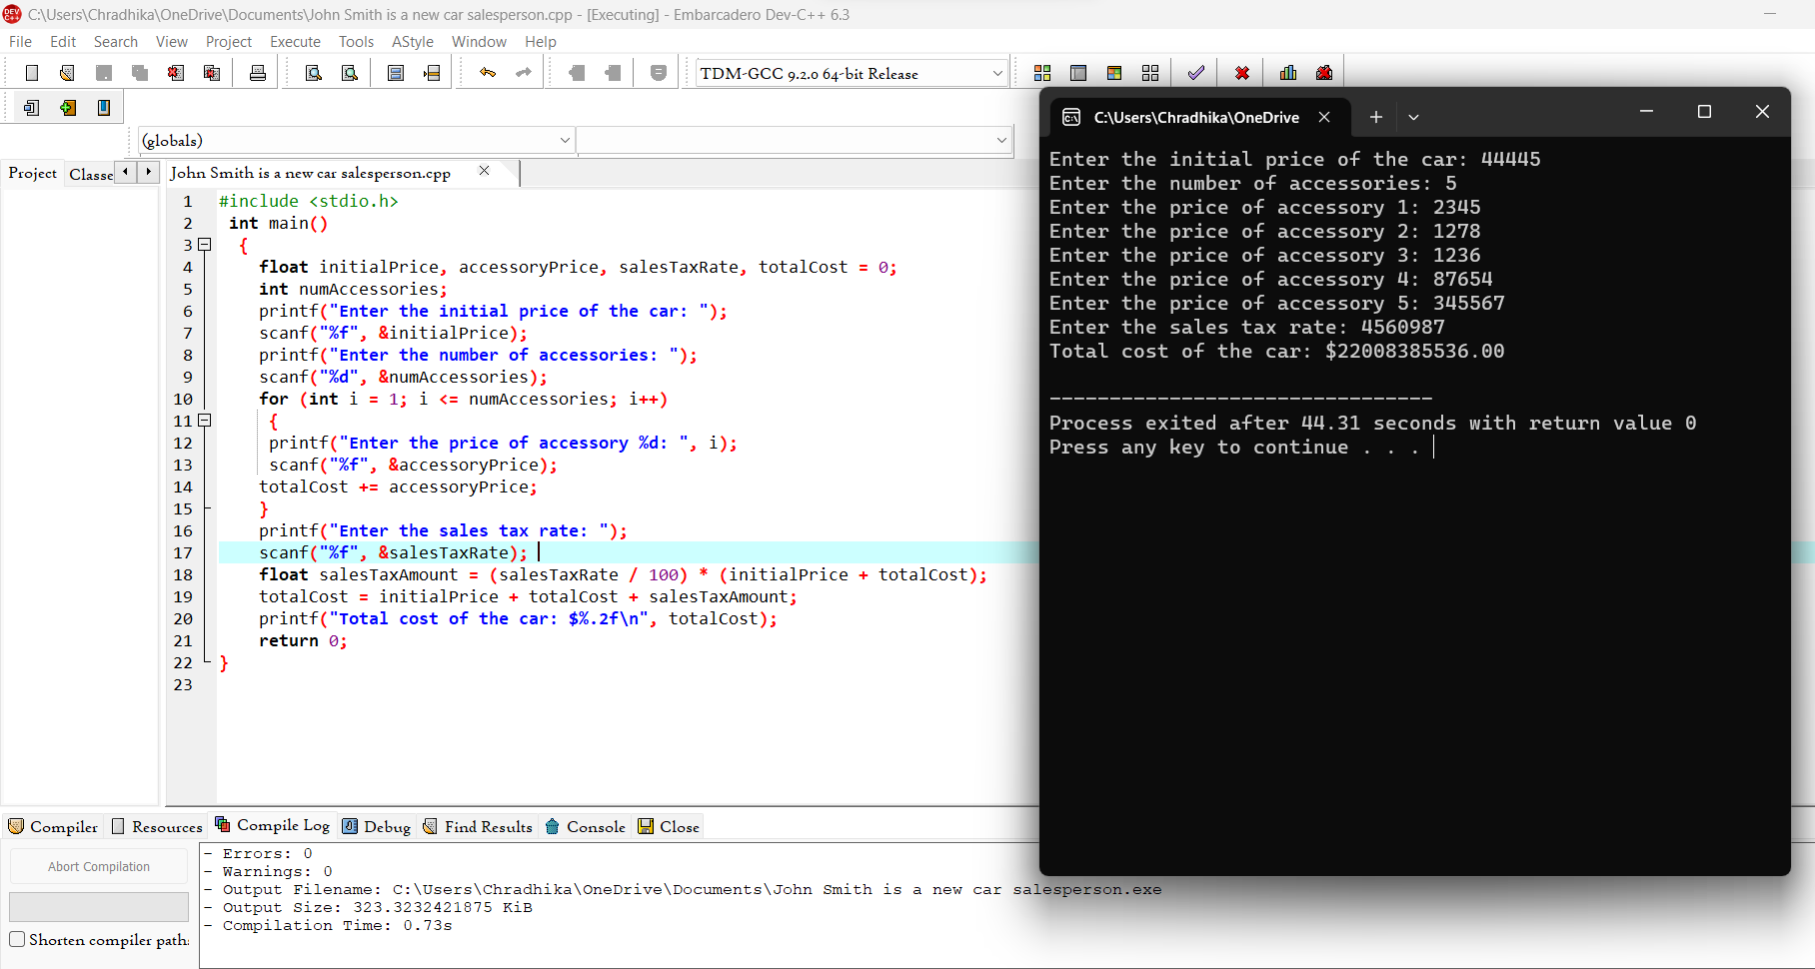

38) The Last Stop Boutique is having a five-day sale.

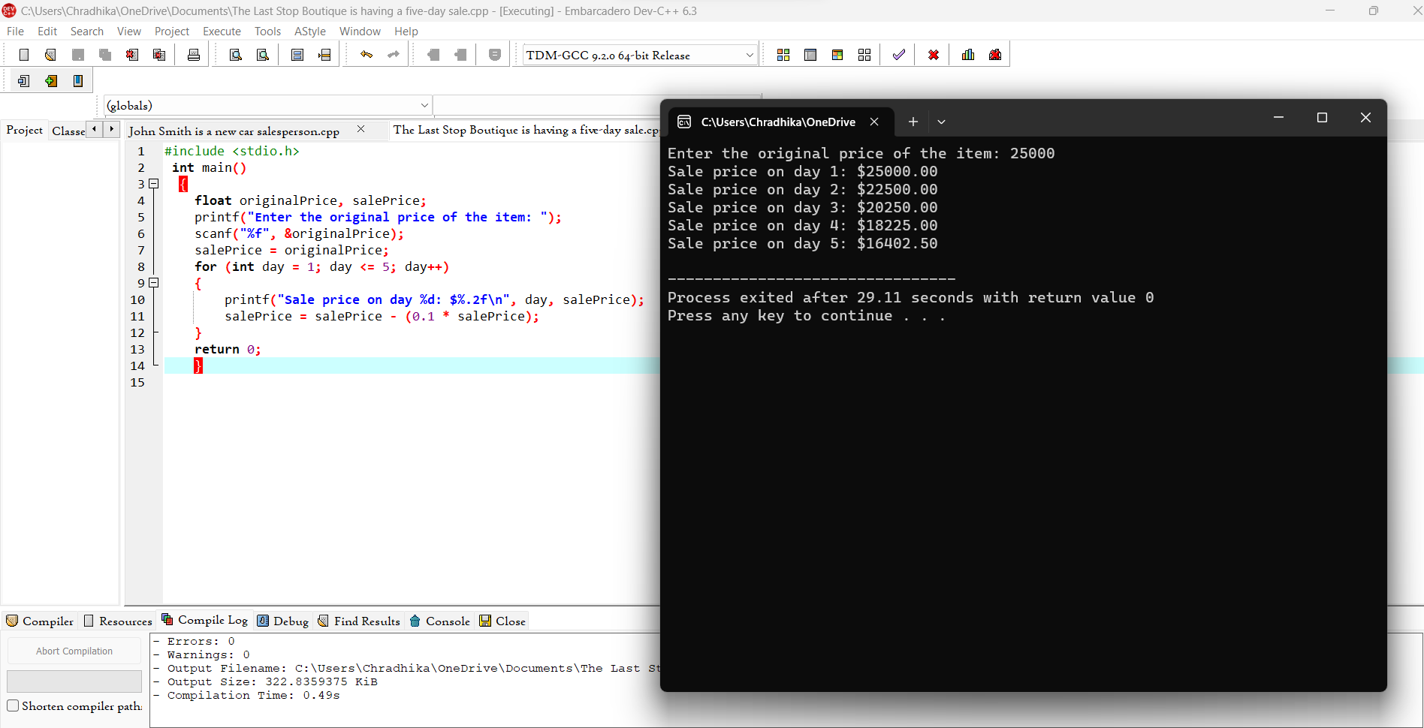

39) Mary Smith, a student, has borrowed $3,000 to help pay her college expenses.

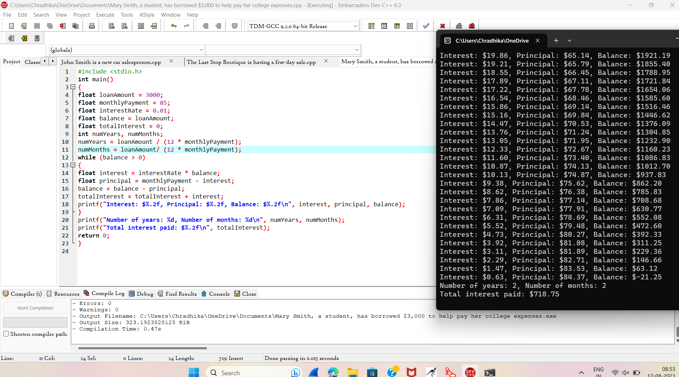

40) find the average miles per gallon on a car after six fill ups at a gas station

